

**Lux Uni- Limpertsberg Campus**

**Monday June 19, 2017**

**19:00**

**Followed by an interactive discussion**

**For further info –www.timeforequality.org**

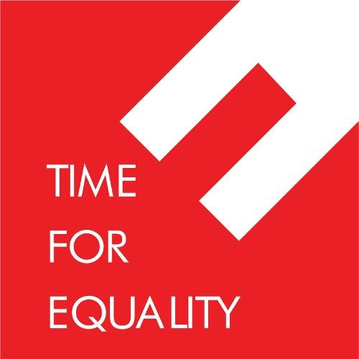[](http://www.ilo.org/global/lang--en/index.htm)

**Inser**